MINISTRY OF SCIENCE AND EDUCATION NATIONAL TECHNICAL UNIVERSITY “KHARKIV POLYTECHNIC INSTITUTE”

DEPARTMENT OF SOFTWARE ENGINEERING AND MANAGEMENT INFORMATION TECHNOLOGIES

Report from “Software Requirements Specification” Discipline “Fundamentals of Software Engineering”

Executed by: Student of group 1.КН.201.8г

CHUKWU IRELE AMORIN

Checked by: Senior lecturer

K.V. Melnik

Kharkiv

Goal: ​Learn how to create Software Requirements Specification Task: ​Create IEEE Software Requirements Specification for your individual task from lab #1.

Software Requirements Specification: 1. Introduction

1.1 Purpose

The purpose of this document is to present a detailed description of the app. It will explain the purpose and features of the system, what the system will do, the constraints under which it must operate. This document is intended for the developers of the system.

1.2 Product Scope

This software will be a Calculator which find the value of “y” depending on different value of “x” and “n”. This system will be designed to maximize users’ productivity by assisting them in such calculations.

1.3 References

IEEE. IEEE Std 830-1998 IEEE Recommended Practice for Software Requirements Specifications. IEEE Computer Society, 1998.

1.4 Overview of the document

The next chapter, the Overall Description section, of this document gives an overview of the functionality of the product. It describes the informal requirements and is used to establish a context for the technical requirements specification in the next chapter. The third chapter, Requirements Specification section, of this document is written primarily for the developers and describes in technical terms the details of the functionality of the product. Both sections of the document describe the same software product in its entirety, but are intended for different audiences and thus use different language.

2. Overall Description 2.1 Product Perspective

The product that is going to be developed is a self-contained new product. It does not need any specific environment or additional software to run correctly.

2.2 Product Functions

- ​Console interface - ​Input data from keyboard - ​Input data from file - ​Setting a specific value of x ​- ​Setting a range of x values - ​Showing result on the screen ​- ​Saving result into a text file

2.4 Operating Environment

Software requirements of the product: - ​Operating system: DOS, Windows 95 or newer, MacOS X 10.1 or newer or any Linux-based distribution

Hardware requirements of the product: - ​Processor: x86, x86-64, PowerPC or ARM; ​- ​Random Access Memory: depends on the operating system of the computer.

Minimum amount of RAM – 48 KB (for DOS). - ​Storage: 85KB free.

3. External Interface Requirements

3.1 User Interfaces

User interface is going to be a console interface. The interface will include tips on usage of the product and line for typing commands.

3.2 Hardware Interfaces

The application will not require any specific hardware interfaces.

3.3 Software Interfaces

The interface will be built using Standard library of C++ called iostream and will use “cout” and “cin” to output/input data from/on the screen. Fstream library will be used to read data from a file and to save results into a file.

3.4 Communications Interfaces

The application will not require any specific communications interfaces.

4. System Features

4.1 Input from keyboard

4.1.1 This feature will allow the user to input values using keyboard. Priority: High. 4.1.2 In order to use this feature, the user must firstly type “input” command, then choose if he wants to use particular x or set of values and then type “keyboard” command.

4.1.3 TBD.

4.2 Input from a file

4.2.1 This feature will allow the user to input values from file. Priority: High. 4.2.2 In order to use this feature, the user must firstly type “input” command, then choose if he wants to use particular x or set of values and then type “file” command. 4.2.3 TBD.

4.3 Show the result in a console

4.3.1 This feature will be used to show the results instantly on the user’s screen. Priority: High. 4.3.2 Outputting the results on the screen will be done automatically after calculating the result. 4.3.3 TBD.

4.4 Save the result in a file

4.4.1 This feature will be used to save the results in a file to use calculated data in the future. Priority: Medium. 4.4.2 In order to use this feature user have to type “yes” after the “Type "yes" to save the answer into a file: ” dialog. This dialog will be shown after calculating the result and showing it in a console. 4.4.3 TBD.

4.5 Menu “About”

4.5.1 This menu will contain the version of the program and an email for feedback. Priority: Low. 4.5.2 To open this menu user must write “about” command in the main menu. 4.5.3 TBD.

5. Other Nonfunctional Requirements 5.1 Performance Requirements No performance requirements

5.2 Safety Requirements

No safety requirements

5.3 Security Requirements

No Security Requirements

5.4 Software Quality Attributes

Here are some quality characteristics for the product that will be important: availability, correctness, flexibility, interoperability, maintainability, reliability, reusability, testability, usability.

5.5 Business Rules

No Business Rules

6. Other Requirements

No other requirements

Appendix A: Glossary

TBD – to be determined

Appendix B: Analysis Models

1) Activity Diagram:

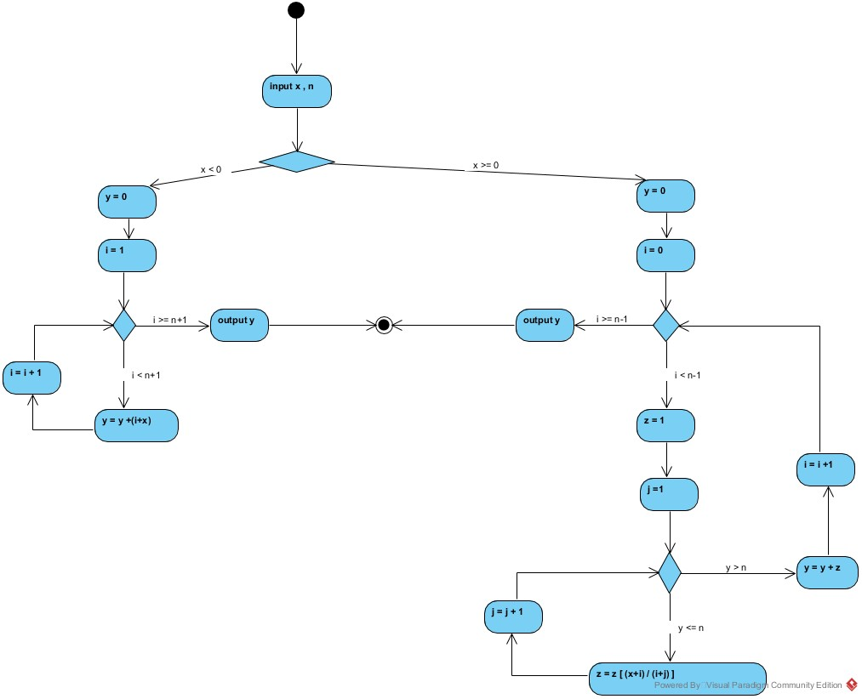

2) Use Case Diagram:

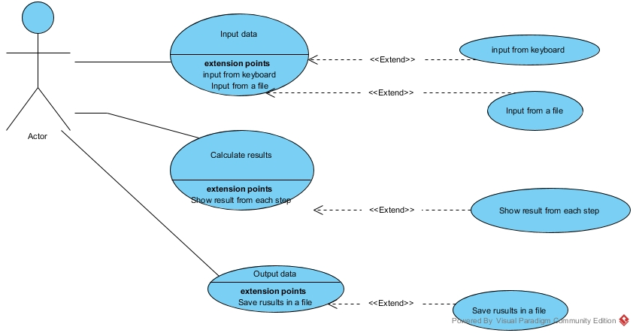

Appendix C: To Be Determined List

4.1.3; 4.2.3; 4.3.3; 4.4.3; 4.5.3.

Conclusion: ​During the process of performing the lab I have learned how to write Software Requirements Specification (IEEE 830).